**Lesson 5 Test the green led module**

Table

1.What do you need to prepare 1

2.Knowledge and principle 2

3.Wiring 3

4.Upload the code and test 4

5.Any questions and suggestions are welcome 7

# 1.What do you need to prepare

|  |  |  |
| --- | --- | --- |
| Components | Quantity | Picture |
| USB cable | 1 |  |
| Green LED module | 2 |  |
| 3 pin wire | 2 |  |
| Control board | 1 |  |

# 2.Knowledge and principle

An LED is a type of diode. All diodes only work if current is flowing in the correct direction and have two Poles. An LED will only work (light up) if the longer pin (+) of LED is connected to the positive output from a power source and the shorter pin is connected to the negative (-). Negative output is also referred to as Ground (GND). This type of component is known as “Polar” (think One-Way Street).

All common 2 lead diodes are the same in this respect. Diodes work only if the voltage of its positive electrode is higher than its negative electrode and there is a narrow range of operating voltage for most all common diodes of 1.9 and 3.4V. If you use much more than 3.3V the LED will be damaged and burn out.

|  |  |  |  |
| --- | --- | --- | --- |
| LED | Voltage | Maximum Current | Recommended current |
| Red | 1.9~2.2V | 20mA | 10mA |
| Green | 2.9~3.4V | 10mA | 5mA |
| Blue | 2.9~3.4V | 10mA | 5mA |
| Volt ampere characteristics conform to diode | | | |

The green LED module schematic diagram as below:



Q1 is a NPN type triode. When a high level signal input to the IN pin, Q1 is switched on and the LED is lit. When the NPN type triode is used in the switching state, most of the emitter is grounded, the collector is connected to a high level, and the base is connected to the control signal. The key point is the voltage between the b pole (base) and the e stage (emitter), for NPN triode, as long as the b pole voltage is higher than 0.7V above the e stage, the triode can be smoothly switched on between the e stage and the c stage.

# 3.Wiring

Using the 3 pin wires to connect the two green led modules with the X6 and X7 connectors on the control board. As the power is relatively small when the LED is working, only the USB cable power supply can be connected, and the external 18650 battery power supply is not required. Wiring connections are as follows: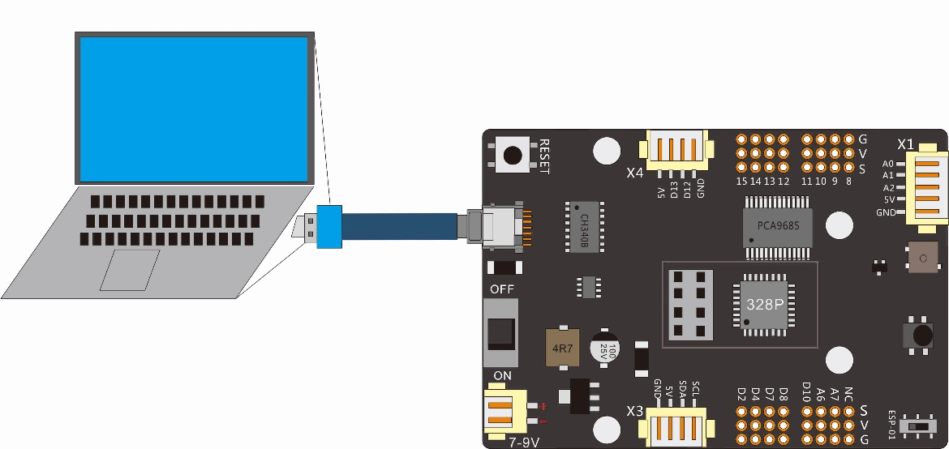

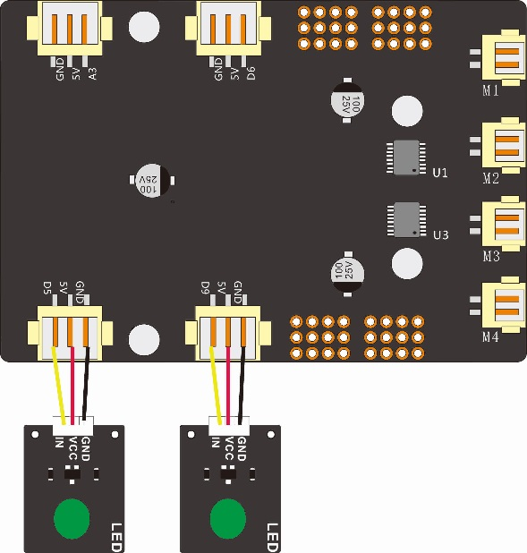

|  |  |
| --- | --- |
| Connect the Green LED module to the control board | |
| Left LED | Control board X7 Connector |
| IN | D5 |
| VCC | 5V |
| GND | GND |
| Right LED | Control board X6 Connector |
| IN | D9 |
| VCC | 5V |
| GND | GND |

# 4.Upload the code and test

The code used in this lesson is placed in the folder：

“ E:\CKK0002-master\Tutorial\sketches”

Double-click the Arduino IDE shortcut on the desktop to open it.

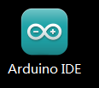

**3_1_light_led**

Click “File”---“open”

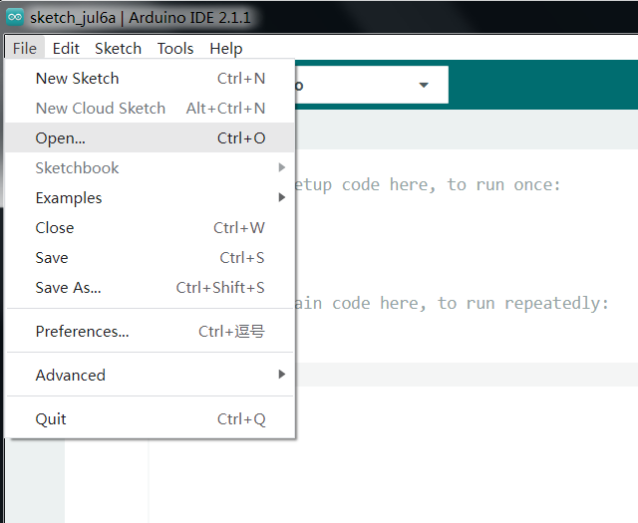

Select the code named 3_1_light_led in the folder：

E:\CKK0002-master\Tutorial\sketches\3_1_light_led

Click“open”， Open the program interface as follows

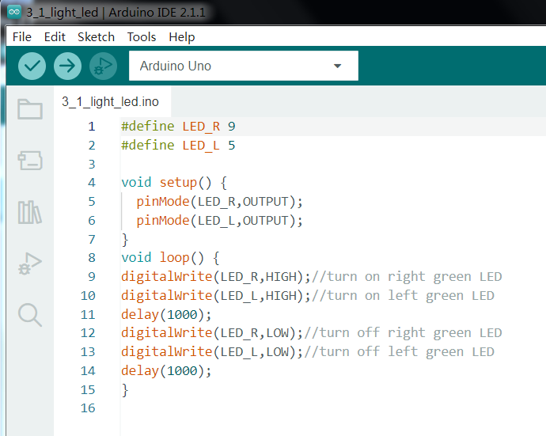

Click the comple button, "Done compiling" appears after the code compiling successfully.

Before uploading the code, turn the ESP-01 switch on the control board to the side away from the "ESP-01" silk screen.

Click the upload button, "Done uploading" appears after the code uploading successfully.

After the code is uploaded successfully,You can see that the two green modules turn on and off the green light in one second cycle.

**Code 3_1_light_led.ino**

#define LED_R 9

#define LED_L 5

void setup() {

  pinMode(LED_R,OUTPUT);

  pinMode(LED_L,OUTPUT);

}

void loop() {

digitalWrite(LED_R,HIGH);//turn on right green LED

digitalWrite(LED_L,HIGH);//turn on left green LED

delay(1000);

digitalWrite(LED_R,LOW);//turn off right green LED

digitalWrite(LED_L,LOW);//turn off left green LED

delay(1000);

}

**3_2_breathing_light**

Select the code named 3_1_light_led in the folder：

E:\CKK0002-master\Tutorial\sketches\3_2_breathing_light

Click“open”， Open the program interface as follows:

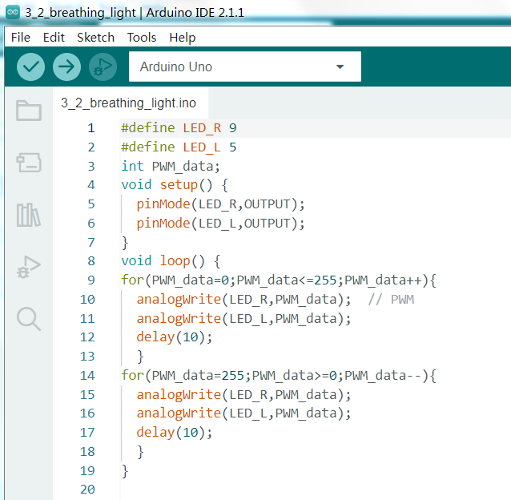

Click the comple button, "Done compiling" appears after the code compiling successfully

Click the upload button, "Done uploading" appears after the code uploading successfully.

After the code is uploaded successfully, You can see that the green light of both modules gradually brightens and then gradually darkens again, in a sequence of cycles.

**Code 3_2_breathing_light.ino**

#define LED_R 9

#define LED_L 5

int PWM_data;

void setup() {

  pinMode(LED_R,OUTPUT);

  pinMode(LED_L,OUTPUT);

}

void loop() {

for(PWM_data=0;PWM_data<=255;PWM_data++){

  analogWrite(LED_R,PWM_data);  // PWM

  analogWrite(LED_L,PWM_data);

  delay(10);

  }

for(PWM_data=255;PWM_data>=0;PWM_data--){

  analogWrite(LED_R,PWM_data);

  analogWrite(LED_L,PWM_data);

  delay(10);

  }

}

# 5.Any questions and suggestions are welcome

THANK YOU for participating in this learning experience!

If you find errors, omissions or you have suggestions and/or questions about this Lesson, please feel free to contact us: [cokoino@outlook.com](mailto:cokoino@outlook.com)

We will make every effort to make changes and correct errors as soon as feasibly possible and publish a revised version.

If you want to learn more about Arduino, Raspberry Pi, Smart Cars, Robotics and other interesting products in science and technology, please continue to visit our website. <http://cokoino.com/>

We will continue to launch fun, cost-effective, innovative and exciting products.

Thank you again for choosing Cokoino products.